Project 1



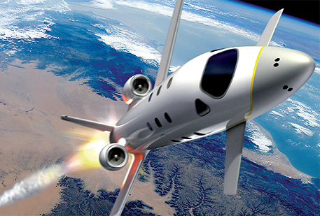

**FDIR**

*Spacecraft fault protection system*

**Euro Team**

|  |  |
| --- | --- |
| **Mikko AHVENNIEMI** | 20096680 |
| **Pierre ALAUZET** | 20096699 |
| **Julien COLIN** | 20096706 |
| **Benoît STARCK** | 20096705 |

**CS554 - Design for Software & Systems**

October 15th, 2009

**Table of contents**

Illustration table 3

**1.** **Problem statement** 4

a. Background 4

References 5

# Illustration table

No table of figures entries found.

**Introduction**

1. **Problem statement**
   1. Background

**Conclusion**

# References

**Web Sites**

**Articles**

**Books**